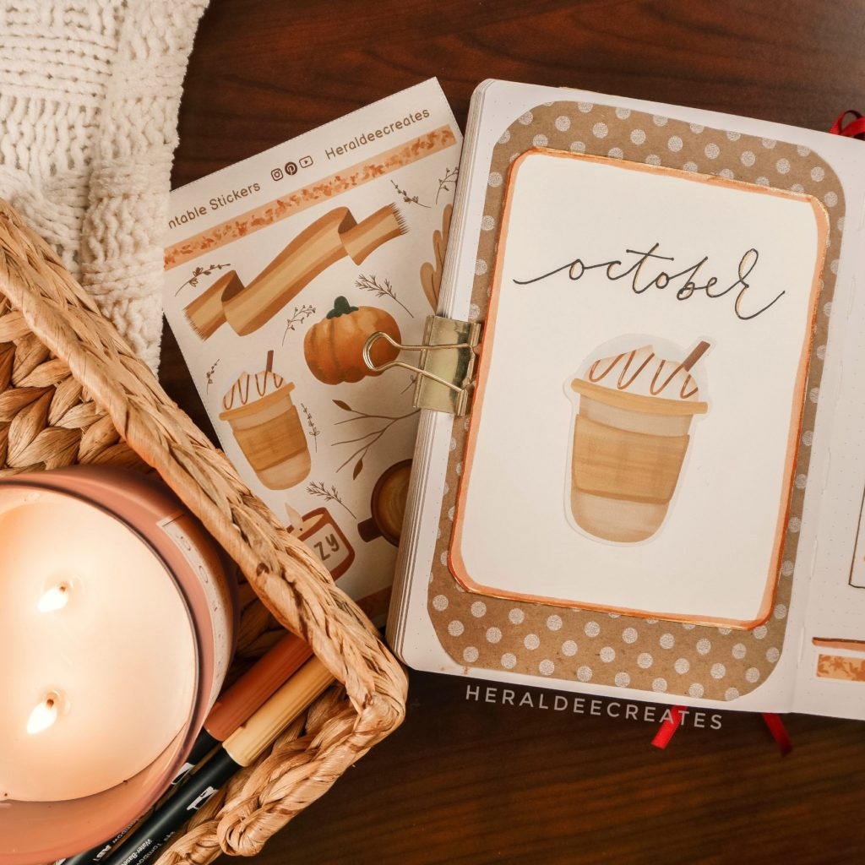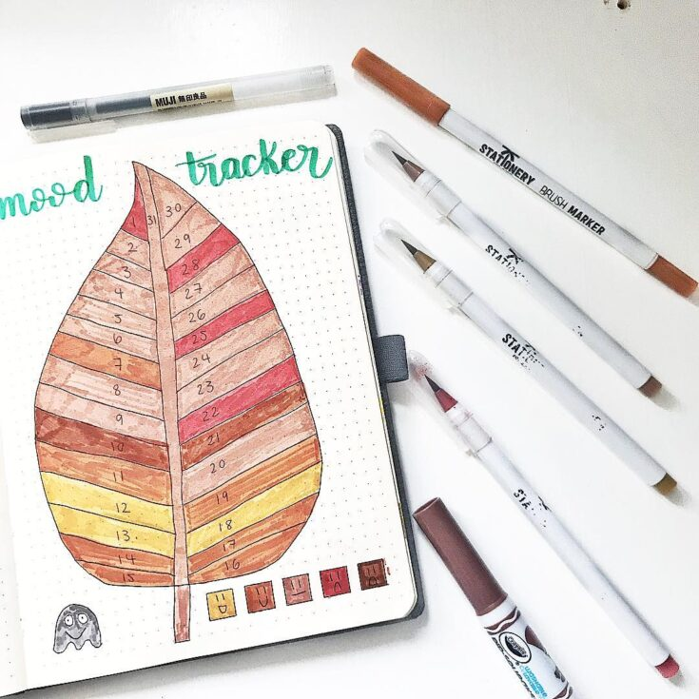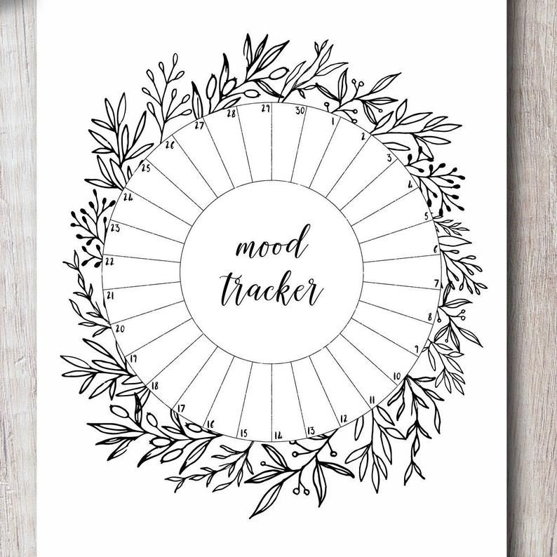**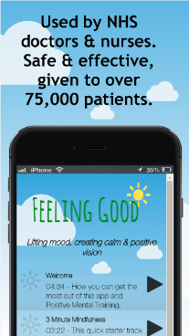**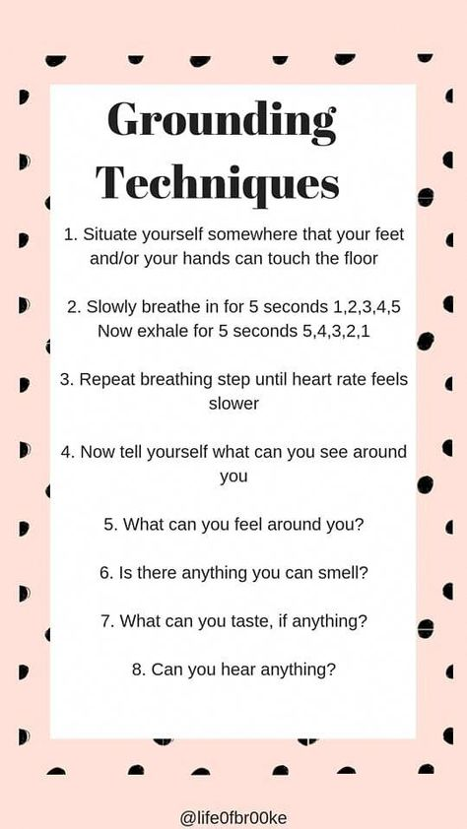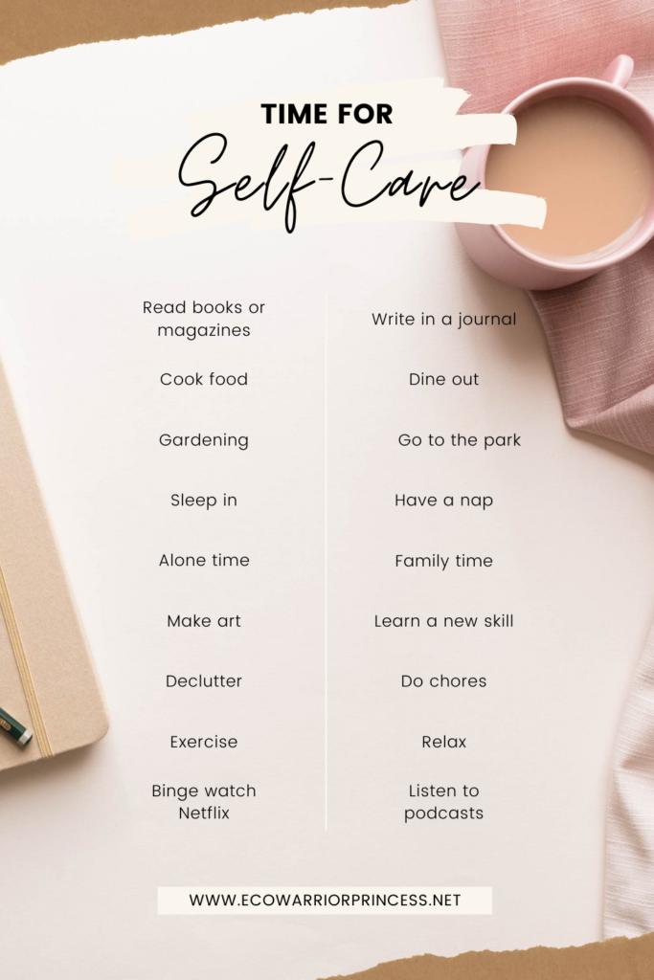



**BEGIN**

MY MENTAL HEALTH PASSPORT

This passport is designed to empower us on a journey alongside our mental health difficulties…

It consists of a series of confidential self-reflection pages, in an effort to take control of our own mental health

It also includes a collation of various Mental Health resources and links, which we believe would be helpful along the way..

Happy travels!

# Welcome to the Mental Health Passport!

**My Basic Mental Health Plan**

I sometimes struggle with these mental health issues…

- Anxiety/ Depression/ ADHD/ Eating disorders/ other

Medications that help me are…

-

My support system – When I feel down, I can call:

- My GP or Mental Health Nurse!

-

-

-

-

This is a completely private self-reflection space, for the user to keep confidential

It is important to identify what triggers us, so that we can avoid the avoidable and understand the unavoidable.

These triggers have affected me in the past (examples below; can we think of others?):

Memories of trauma Workplace stress Feeling left out Feeling judged Social media

My Triggers

These are techniques that have helped me feel better in the past…

My Coping Techniques

Taking a deep breath Listening to music Talking to a friend Exercise

A daily mood tracker may also help us take better control of our emotions

(We could pick a colour to represent each mood, and colour in the day of the month: a key may be helpful!)

# Mood Tracker

**Get the app!** Downloading the **app is free**

**1.** **Visit** your app store on your phone or tablet.

**2**. **Search** on ‘feeling good’ and look for the logo with a blue sky and sun (see picture above)

**3**. **Install** the app free to your device. It comes with free stuff.

**4. Unlock** the rest of the tracks by putting the **username and password** below into the login boxes at the foot of the ‘download’ tab. (NB this username and password are *only* for this app.)

5. On an **ipad/iphone** you need to **close the keypad** (press done) **before** pressing ‘submit’

**6.** **Complete the questionnaire** –mood scorefor your interest,helpful to us, all results are anonymous.

**NB** your device needs to be set up to use the app store, this requires registering with Google or apple.

**My app login username My app login password**

**edinchpa**

**positive**

# The Feeling Good App

MIND – Helpful information leaflets and stories

<https://www.mind.org.uk/information-support/>

ITHRIVE – Edinburgh-based online space for Mental Health Resources

<https://ithriveedinburgh.org.uk/>

Resource Websites

Below are some additional particularly helpful mental health resource websites

(A more comprehensive list of resources is attached towards the end of the passport)

Recommended by Cognitive Behavioral Therapy

Take a deep breath, as deep as you can…

Clench your left hand as hard as you can…

Feel the pressure in your left hand and chest as you hold for a few moments

Then breathe out, close your eyes gently and feel the relaxation spread through your body

Take slow deep breaths in and out – and relax

**Inspiration from the Feeling Good App**

Prioritizing self-care can be immensely helpful to mental health

Mental Health is a constant and evolving journey.

There are a variety of tools to help us along the way –conversations with our healthcare team and loved ones, self-help measures, medications and resources.

Listed below is a collation of helpful resources, support groups and contact details that we recommend..

Resources for counseling and support:

**NE Edinburgh Counseling Service** [www.neecscounselling.org.uk](http://www.neecscounselling.org.uk) Tel 0131 557 4478

31 Haddington Place (on Leith Walk) EH7 4AG

**Health in Mind** [www.health-in-mind.org.uk](http://www.health-in-mind.org.uk) 0131 225 8508 Resource Centre 40 Shandwick Place

Offer befriending; support groups – ethnic minorities, abuse

**Stress Control Classes** x 6 lectures: <https://services.nhslothian.scot/stresscontrol/Pages/default.aspx> See website for info about this CBT based course, dates & various venues –> Phone Health-in-Mind to book place

**Mental Health Information Station** = **Drop in** = Thursdays 11am–3pm Advice, guidance, info & coffee

For anyone affected by mental health issues. Walpole Hall St Mary’s Cathedral Palmerston Place EH12 54W

Specific support services

**Saheliya** Ethnic Minority Women’s support <http://www.saheliya.co.uk/> 125 McDonald Rd 0131 556 9302

**CRUSE** Bereavement counseling <http://www.crusescotland.org.uk/> Tel 0845 600 2227

**Vocal** Counseling & support for Carers [www.vocal.org.uk](http://www.vocal.org.uk) 0131 622 6666 Carers’ Hub 60 Leith Walk

**LGBT** <http://www.lgbthealth.org.uk/> 03001232523

**ELCA** Alcohol <http://edspace.org.uk/service/edinburgh-lothian-council-on-alcohol/> 0131 337 81886

**The Recovery Hub** - Drug or alcohol problems – drop in daily at 5 Links Place EH6 7EZ 0131 554 7516

**Relationship counseling** <http://www.bright-light.org.uk/> 0131 556 1527 9a Dundas St EH3 6QG

Child and Adolescent Mental Health – general resources

**Young Minds** Information and advice on young people’s emotional wellbeing and mental health [www.youngminds.org.uk](www.youngminds.org.uk%20) Tel: 0808 802 5544

[www.ru-ok.org.uk](www.ru-ok.org.uk%20) - Mental Health charity; Information on relaxation, anger management, etc.

[www.rcpsych.ac.uk/mentalhealthinfo/youngpeople.aspx](www.rcpsych.ac.uk/mentalhealthinfo/youngpeople.aspx%20) - Produced by Royal College of Psychiatrists; Search subjects for leaflets and fact sheets about many subjects from depression to sleep problems. Also pages specific to child and adolescent mental health- look under mental health and growing up for parent/child friendly leaflets

**Childline** - safety and well being of young people. The help and advice section has pages about bullying, abuse, homelessness, suicide and much more[www.childline.org.uk](file:///C:\Users\michelle.perera\Desktop\www.childline.org.uk) Tel. 0800 1111

**Health Opportunities Team** - Edinburgh based charity supporting young people aged 12-25 to improve their physical, sexual and emotional health and wellbeing. Trauma informed work includes, therapeutic 1:1, 'Feel Good' groups, weekly drop-ins, 1:1 and group work with young people affected by their own or parental substance use, RSHP education and group work in schools [www.health-opportunities.org.uk](www.health-opportunities.org.uk%20) 1a Queens Walk, EH16 4EA. Tel 0131 4684600

Useful phone numbers

**Samaritans Free phone** **116 123** 24-hour Helpline [www.samaritans.org](http://www.samaritans.org)

**Breathing Space** **0800 83 85 87** Confidential Phone linefor anyone feeling low or anxious

Open 7days: Mon-Thurs: 6pm -2am Fri-Mon 6pm – 6am <https://breathingspace.scot>/

**Living Life** Telephone appointment support for >16 yrs. with stress, low mood or anxiety, by self-help coaches & therapists, CBT approach 4-9 sessions Tel 0800328 9655 <https://breathingspace.scot/living-life/>

**Women’s Aid** 0800 027 1234 or 0131 315 8110 [www.scottishwomensaid.co.uk](http://www.scottishwomensaid.co.uk)

**Victim Support** 0845 603 9213

**Citizens Advice Bureau** Nearest: **Leith** 23 Dalmeny St 0131 510 5510 and 58 **Dundas** St 0131 510 5510

<https://www.citizensadvice.org.uk/scotland/> Independent advice including benefits, welfare, debt, legal rights

**GOV.UK**  <https://www.gov.uk/> Info on government services e.g. benefits, debt, births & deaths, childcare

Other Self Help Resources

**Help Guide** <http://www.helpguide.org> (info - including Burnout, Separation, Bullying, Anger)

**Royal College of Psychiatrists** [www.rcpsych.ac.uk/mentalhealthinformation.aspx](http://www.rcpsych.ac.uk/mentalhealthinformation.aspx)

Up-to-date information, wide range of printable leaflets & resources on website.

**Living Life to the Full** <https://llttf.com/>

Online version of **CBT** Cognitive Based Therapy self help materials, relaxation sound & modules

**Mood Gym** [http://www.moodgym.anu.edu.au/](http://www.moodgym.anu.edu.au/" \t "_blank)

Australian website which uses **CBT** to develop skills for preventing & coping with depression

IN an emergency, I would call:

**MHAS Mental Health Assessment Service** (REH 24hrs) 0131 **537 6000** Ask for Emergency Team

**NHS 24 Free** phone **111** 24 hour helpline for medical problems. [www.nhsinform.co.uk](http://www.nhsinform.co.uk)

Edinburgh Crisis Center [**0808 801 0414**](tel:0808%20801%200414) 24 hours helpline or text [07974429075](tel:07974429075)